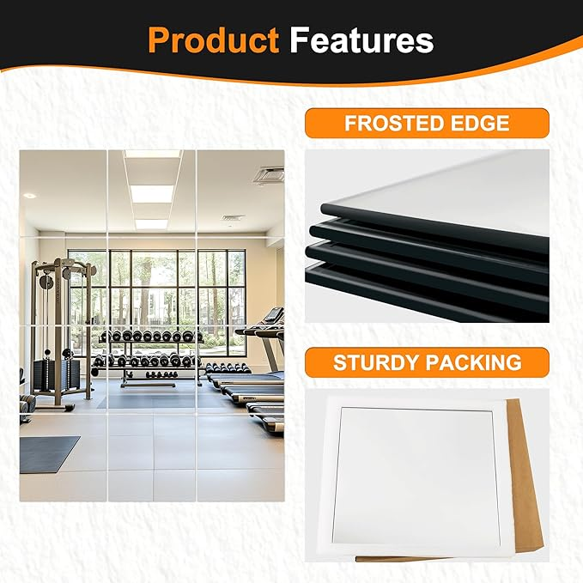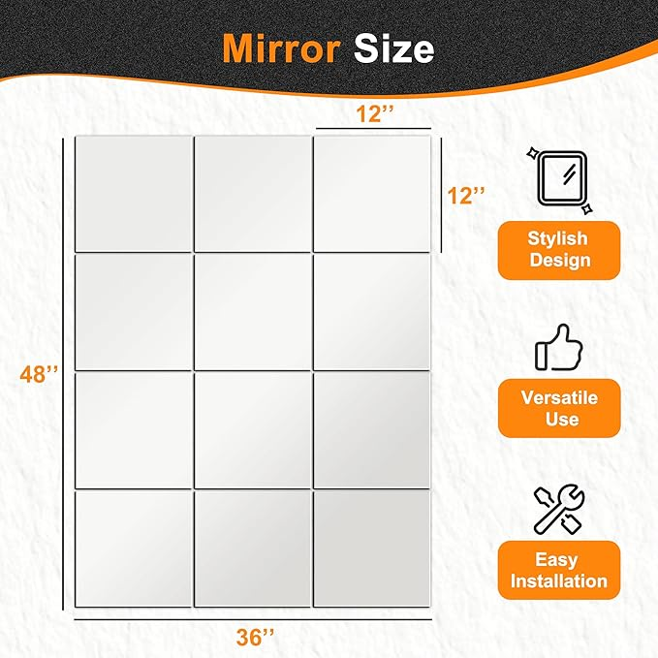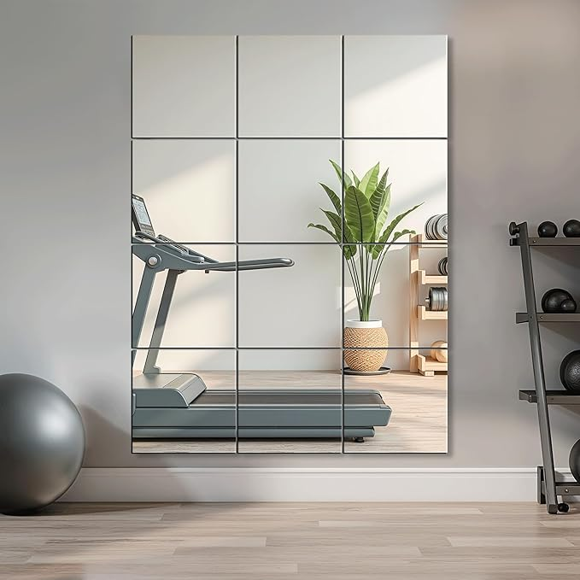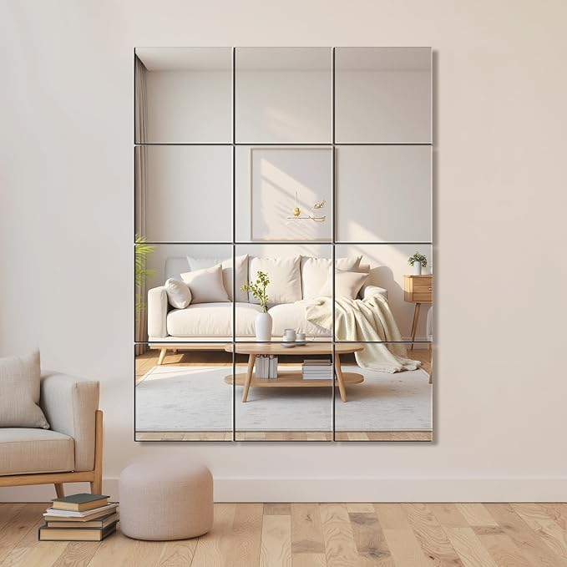

Delma Home Gym Mirrors, 12'' x 12'' Glass Mirror Tiles (12 PCS), Square Large Wall Mirror for Home Gym, Bedroom, Door,Bathroom, Frameless Mirror Sets

**PRODUCT DESCRIPTION:**

|  |  |
| --- | --- |
| Brand | Delma |
| Room Type | Living Room |
| Shape | Square |
| Product Dimensions | 12"L x 12"W |
| Frame Material | Unframed |

**About this item**

* HD REFLECTIONS: This frameless mirror tiles are made of HD float glass, better reflection, more resistant. Wall mirror edge was frosted, which make this mirror more secure.
* EASY TO INSTALL: Wall mirrors come with powerful self adhesive Foam Tape & Glue, easy to use. And please clean your wall before installation, make sure the surface is flat, dry, without any powder.
* Gym mirror sheets size: 12'' x 12'', Total 12 pieces. We use the very strong packaging with foam EVA material to ensure no breakage in transit.
* WIDE APPLICATION: Square mirror tiles could decorate bathroom, home gym, bedroom, which can be mounted on wall,tiles,closets,doors.
* NOTE: Some powder-coated walls are not suitable. If mirror decors fall off the wall, PLEASE CONTACT US and we offer exchange or refund services.